Sample Paper BE ELECT CIV MECH

Instructions

Total number of Sections = 04
Total number of Questions = 36

The Sample Paper is totally MCQ Based, consisting of Question statements and four/five (i.e. A-D/E) Answer choices. You have to select the correct answer choice.

Instructions about Answer Sheet + Right Answer Keys are at the end of Exercise.

Note: This sample paper does not include quantitatively the same number of questions as there would be in actual paper. This is merely meant to provide conceptual guidance to the users or prospective candidates.

VERBAL

This section assesses the skills of English Language. Main stress of this section is on the grammar, vocabulary and reading comprehension.

Complete the sentences by choosing the most appropriate word, from the given lettered choices (A to D) below each.

- Earthquakes cause vibrations to pass _________ around the earth in wave form.

- through
- through the
- through an
- through and

- The first engine _________ heat to drive a machine was the steam engine.

- made use of
- to make use of
- of using
- of making use

Each question below consists of a related pair of words, followed by five lettered pairs of words. Select the lettered pair that best expresses a relationship similar to that expressed in the original pair.

- MAN: ROBOT::

- original: counterfeit
- true: sham
- brain: computer
- object: image

- SLAKE: THIRST::

- accelerate: speed
- splinter: wood
- douse: fire
- pledge: loyalty

Choose the lettered word or phrase that is most nearly opposite in meaning to the word in capital letters.

- COVETOUS:

- Greedy
- sympathetic
- generous
- niggardly

Choose the word most similar in meaning to the capitalized ones.

- BATTERY:

- ambush
- corner
- precarious
- group
- delirium

Read the passage to answer question 7-10

Since the 1980s, the biggest influence on business has been electronic technology.
Computers are being used for inventory control, sales analysis and forecasting, distribution control, and budget analysis. At-home electronic shopping is becoming commonplace. With this system, consumers view merchandise on a computer monitor and then use a modem, which links the computer to a telephone line, to signal the goods they want to order. Just as traveling salesman once brought wares to the home, electronic technology makes it possible for modern consumers to see and select from any array of goods in their homes.

- The word “forecasting” is closest in meaning to

- prediction
- efficiency
- accounting
- decision making

- The word “modem” refers to a type of

- electronic shopping
- electronic device
- telephone
- computer screen

- The word “wares” is closest in meaning to

- clothing
- items for sale
- messages
- household appliances
- The word “array” is closest in meaning to

- pair
- container
- category
- collection

ANALYTICAL REASONING

The questions in this section need simple analysis of the given data and logical reasoning of the candidate. Each question or group of questions is based on a passage or set of conditions, and the candidate has to select the best answer choice.

Now Sony Electronics brings tomorrow's technology to today's home stereo. The same space-age circuitry used by the Wanderer spacecraft to send images of the most distant planets back to earth has been incorporated in the new Sony X-2700 stereo system. If your home entertainment is important to you, why settle for an old-fashioned stereo system when the Sony X-2700 is priced at only a few rupees more?

- The most serious logical weakness of this argument is its failure to

- provide technical data on the manufacturing specifications of the Sony X-2700
- show the relevance of space-age circuitry to the requirements of home stereo
- specify the exact price difference between the Sony X-2700 and old-fashioned stereo systems
- acknowledge the contributions of scientists in the space program to the development of the advanced circuitry mentioned
- explain the precise meaning of the technical terms used

According to Albert Einstein's famous theory of relativity, time travel is theoretically possible. Assuming that time travel were to be made possible through some technological breakthrough, it would be advantageous to send someone back in time to prevent the assassination of Archduke Franz Ferdinand in 1914 and thus keep World War I from ever occurring.

- The argument above makes which of the following assumptions?

- It is not possible to alter a significant current in world history merely by changing a single event
- The technology necessary for time travel is likely to be developed in the near future
- If Franz Ferdinand had not been assassinated, some other catalytic event would have led to the start of World War I
- The assassination of Franz Ferdinand was the crucial event that triggered the start of Word War I
- If time travel were to be developed in the future, evidence of time travelers would be apparent to those living today

A placebo is a chemically inert substance prescribed more for the mental relief of a patient than for its effect on the patient's physical disorder. It is prescribed in the hope of instilling in the patient a positive attitude toward prospects for his or her recovery. In some cases, the placebo actually produces improvement in the patient's condition. In discussing the use and effect of placebos, a well-known medical researcher recently paid physicians the somewhat offbeat compliment of saying that physicians were the ultimate placebo.

- By comparing a physician to a placebo, the researcher sought to imply that

- physicians should always maintain and communicate an optimistic attitude toward their patients, regardless of the prognosis
- the health of some patients can improve simply from their knowledge that they are under a physician's care
- many patients actually suffer from imagined illnesses that are best treated by placebos
- physicians could prescribe less medication and achieve the same effect
- it is difficult to determine what, if any, effect a physician's behavior has on a patient's condition

Manufacturers of household appliances in China are introducing an array of computerized technologies in the work of many of their factories in an effort to regain a lead eroded by international competition. On the basis of changes that have already taken place, experts predict a golden age for the consumer of better-designed and better-built products.

- Which of the following, if true, would LEAST support the experts’ claim that appliances produced by computerized technologies will be better built?

- Computerized inventory procedures ensure that parts are ordered in sufficient quantities and that production moves smoothly and consistently
- Computer-directed machines carry out repetitive tasks with the result that errors due to human fatigue are eliminated
- Computer-controlled ultrasound devices are better able to detect hidden flaws and defects that require repair than are human inspectors
- The flow of heat used to weld parts together is more consistent when directed by computer programs and results in a more accurate and uniform weld
- Computer-driven screwdrivers ensure that screws used in appliances will be consistently tight

Questions 15-20

In a telecommunications-cable assembly plant, cables are assembled by twisting plastic-coated wires together. There are wires of exactly six different solid colors—red, yellow, violet, green, white, and black. Wires must be assembled into single cables according to the following rules:

Each cable must contain at least three wires and wires of at least three different colors.
At most two wires in a single cable can be black.
At most two wires in a single cable can be white.
There can be at most one wire of each of the other colors in a single cable.
If one wire is red, then one wire must be yellow.
If one wire is violet, then no wire can be green.

- Which of the following could be the-complete set of wires in an acceptable cable?

- A green wire, a white wire, and a violet wire
- A violet wire, a black wire, and a white wire
- A red wire, a black wire, and a green wire
- A yellow wire and exactly two black wires
- Exactly two black wires and exactly two white wires

- The maximum number of wires that can be used in an acceptable cable is

- 8
- 7
- 6
- 5
- 4

- If exactly one black wire and exactly one white wire are used in an assembled cable, which of the following must be true?

- The cable contains no more than five wires
- The cable contains exactly six wires
- The cable contains a yellow wire
- The cable does not contain a red wire
- The cable does not contain a violet wire

- If a white wire and a violet wire must be among the wires chosen for a particular cable, any of the following pairs of wires could complete the cable EXCEPT a

- black wire and a second white wire
- yellow wire and a second white wire
- yellow wire and a black wire
- red wire and a yellow wire
- red wire and a black wire

- If an assembled cable consists of exactly five wires, each a different color, it could be true that a color NOT used is

- black
- white
- green
- red
- yellow

- If there is an additional requirement that violet must be used if yellow is used, which of the following must be true?

- No cable contains fewer than six wires
- No cable contains more than five wires
- Green is never used if red is used
- Red is always used if violet is used
- Black is used exactly once if yellow is used

QUANTITATIVE

This section assesses the basic skills of Quantitative. Main stress of this section is on the arithmetic, algebra and geometry.

- Eric’s test scores were 98, 95, 84, 100, and 92. What would he need on his next test to have an average of 94?

- 90
- 92
- 95
- 100
- It is not possible to get that average

- The circumference of a circle whose diameter is 7 inches is approximately

- 22 inches
- 28 inches
- 38 inches
- 154 inches
- 14 inches

- Express as a ratio in simplest form: 5 feet to 3 inches

- 
- 
- 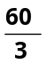
- 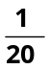
- 20

- Which of the following is closest to the value of 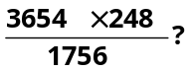

- 50
- 500
- 5,000
- 5

- If 3x + 2 = 12, find x - 

- 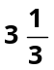
- 3
- 10
- 4
- What is 15% of 32?

- 4
- 3.50
- 4.80
- 3.80

- Solve the following equation for x

3x-5=3+2x

- 8
- 10
- 6
- 14

- At a dairy it takes 90 seconds to fill 30 one-gallon jugs of milk. How many minutes does it take to fill 90 jugs of milk?

- 1
- 3
- 3.5
- 4
- 4.5

- A number that is divisible by both 6 and 8 is also divisible by

- 5
- 9
- 11
- 16
- 24

- What is the average (arithmetic mean) of 8x + 5, -3x + 9, 0 and 7x-2?

- 3x + 1
- 3x + 3
- 4x + 1
- 4x + 4
- 12x + 12

SUBJECT

This section assesses the basic skills of Professional Qualification(s) of the candidate.

The main subjects are:

- The product of all the three cube roots of unity is ____________.

- 0
- 1
- -1
- 3

- Form of a quadratic equation with roots 3 and 4 is:

- x+7x+12=0
- x-7x-12=0
- x+7x-12=0
- x-7x+12=0

- A bomb is dropped from an airplane moving horizontally with a speed of 200 km/h. If the air resistance is negligible, the bomb will reach the ground in 5 s, what is the altitude of the plane approximately: (g= 9.8 m/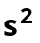)

- 50 m
- 75 m
- 122.5 m
- 250 m
- 300 m

- How many types of modulations are possible with sinusoidal carrier?

- One
- Two
- Three
- Four

- High refractive index glass, intended to be used for manufacturing of optical instruments, is:

- Jena glass
- Flint glass
- Crook’s glass
- Borosilicate glass
- Pyrex glass

- During industrial processes, waste management strategies are primarily opted for:

- Resource leveling
- Resource optimization
- Resource scraping
- Process monitoring
- Process controlling

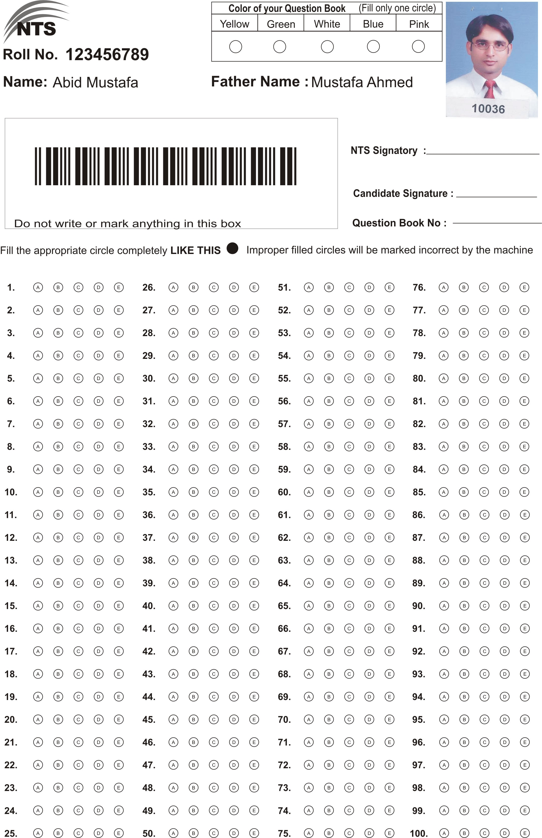
HOW TO FILL THE ANSWER SHEET?

One page printed Answer Sheet is provided to answer the questions. USE ONLY BALL PEN (BLACK/ BLUE) TO SHADE/FILL THE CIRCLES.

How to fill an Answer: Answer sheet contains five circles containing five options of answer for one questions, containing alphabets from A to E inside, against each question number. The candidate has to completely shade/fill one circle that s/he thinks is correct. For example the candidate feels that the correct answer of the given question is ‘A’, then s/he may shade/fill the circle containing alphabet ‘A’ with ball pen like this:

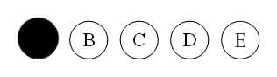

“A” Filled

Incorrect Filling:

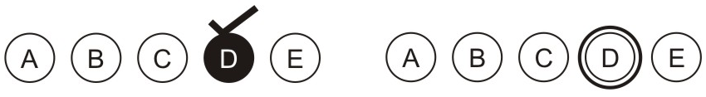

Personal Data on Answer Sheet

The Answer Sheet contains personal data of candidate on the top of the sheet. It has candidates’. NAME, FATHER NAME and ROLL NO. The candidate is required to critically check these fields and sign in the required space. If any field of personal information is found in-correct the candidate MUST inform the invigilator present around.

Write down your Question booklet No. given on the right top corner of the Question booklet in the column of “Question book No”.

Fill the circle “color of your question book”. Fill the right circle otherwise you will confuse the marking process which can have negative effects.

Answer Key

Q #. | Right Choice | Q #. | Right Choice
1 | D | 26 | C
2 | B | 27 | A
3 | C | 28 | E
4 | C | 29 | E
5 | C | 30 | B
6 | D | 31 | B
7 | A | 32 | D
8 | B | 33 | C
9 | B | 34 | C
10 | D | 35 | B
11 | B | 36 | B
12 | D
13 | B
14 | A
15 | B
16 | B
17 | A
18 | E
19 | C
20 | C
21 | C
22 | A
23 | E
24 | B
25 | B

